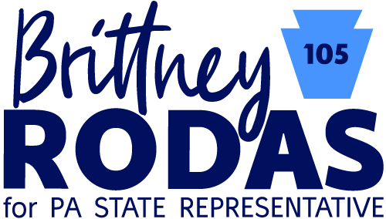

Welcome to the email list for the Brittney Rodas for State House campaign! We’re so excited to introduce you to our team and to Brittney herself.

So who is Brittney Rodas?

Brittney grew up in PA, in a working-class family that struggled with the same challenges that so many Americans are facing today. She is the daughter of a veteran and union steelworker father and was raised by a single mom, who worked multiple low-wage jobs to support her family.

Brittney put herself through school to earn a Bachelor’s Degree in Sociology and a Masters in Public Administration from Penn State. She then became an intern in the Capitol and worked her way up over the past five years to become a Policy Analyst. She saw firsthand how corruption and partisan stalemate blocked legislation that could improve and even save Pennsylvanians’ lives.

Healthcare is an issue that is particularly close to her heart. When her father got sick, he missed the cutoff for Medicaid assistance by only [$7 dollars](https://www.youtube.com/watch?v=c_BJxA6UWC8&t=1s). After his death, Brittney decided to run for State Rep in part to fight for caps on prescription drug prices, an end to surprise medical billing, and to protect Medicaid Expansion and the Children’s Health Insurance Program (CHIP) from constant Republican attempts to defund these life-saving programs.

Speaking of which, I also want to share a little bit about what we’re up against:

The Republican incumbent for this race has not only [put the lives and families of his Democratic colleagues at risk for contracting Covid-19](https://www.nytimes.com/2020/05/28/us/politics/andrew-lewis-brian-sims-pa-house-coronavirus.html), his voting record shows the same disregard for the lives and rights of Pennsylvanians:

* He voted to [bring guns into schools](https://votesmart.org/bill/26648/68363/179510/andrew-lewis-voted-yea-passage-sb-621-authorizes-schools-to-arm-security-guards#68363) and allow school police to [make arrests](https://votesmart.org/bill/27328/70255/179510/andrew-lewis-voted-yea-concurrence-vote-with-amendment-hb-49-authorizes-school-police-to-make-arrests#70255).
* He voted to [repeal a general assistance program](https://votesmart.org/bill/26689/67750/179510/andrew-lewis-voted-yea-passage-hb-33-repeals-a-general-assistance-program-for-adults-with-disabilities#67750) for adults with disabilities.
* He voted to [require a funeral for abortion remains](https://votesmart.org/bill/27425/70212/179510/andrew-lewis-voted-yea-passage-hb-1890-requires-a-funeral-for-or-the-cremation-of-abortion-remains#70212).
* And he [co-sponsored a bill](https://votesmart.org/bill/28043/72665/179510/andrew-lewis-sponsored-hr-836-establishes-a-resolution-to-partially-terminate-the-governors-emergency-declaration#72665) to open up PA businesses before it was safe.

Each of these pieces of legislation passed through the Republican-majority State House.

**But we are only nine seats away from turning the State House Blue.**

In 2018, the Democratic nominee for State House in the district lost by only 512 votes.

We have the chance this November not only to remove a dishonest and harmful politician from office, but to bring in a fresh voice for Pennsylvanians with real people and real concerns as her priority.

We are so grateful and excited for you to join us in this fight. This email list will serve as a way for us to share information and updates as the campaign progresses, and it’s also an easy way to get in touch with Brittney and the team, so feel free to reply with any questions or thoughts you may have!

For now, visit [rodasforpa.com](https://rodasforpa.com/) to learn more.

We look forward to hearing from you!

--

Gabi Rubinstein

Finance Team

Britney Rodas for State Representative

609.847.9932 / she.her